***Question 7:***

*Use only bitwise operators  and control statments for the following:*

*a. Check whether two numbers are equal*

*b. Check whether a number is odd or even*

*c. Check whether a number is positive or negative (note: the first bit is zero if it is positive)*

***Codes:***

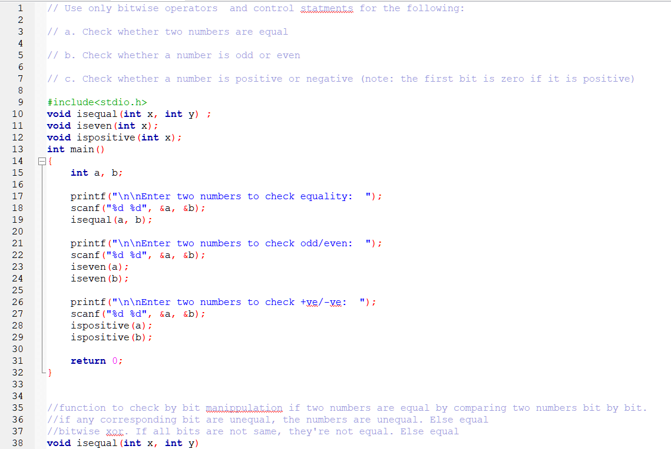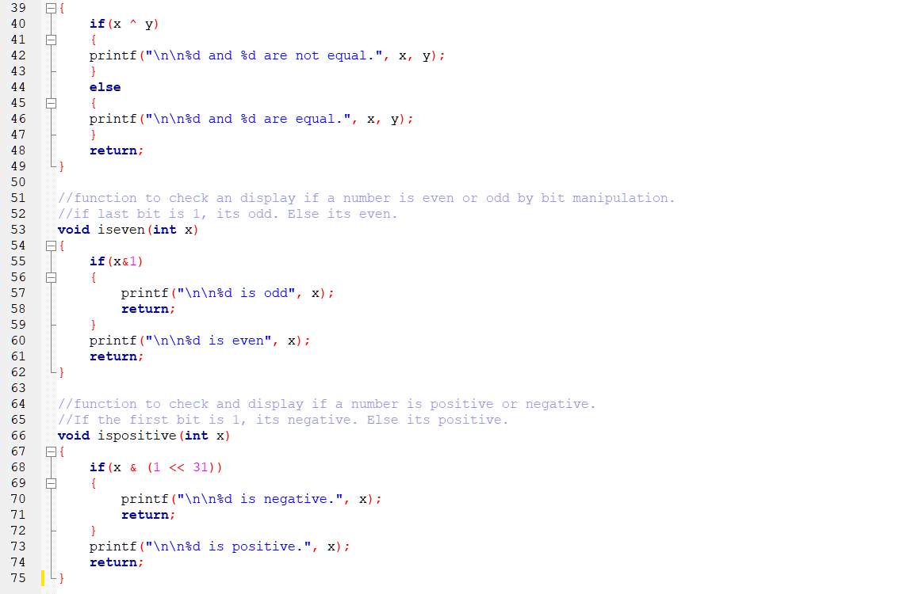

***Test case 1:***

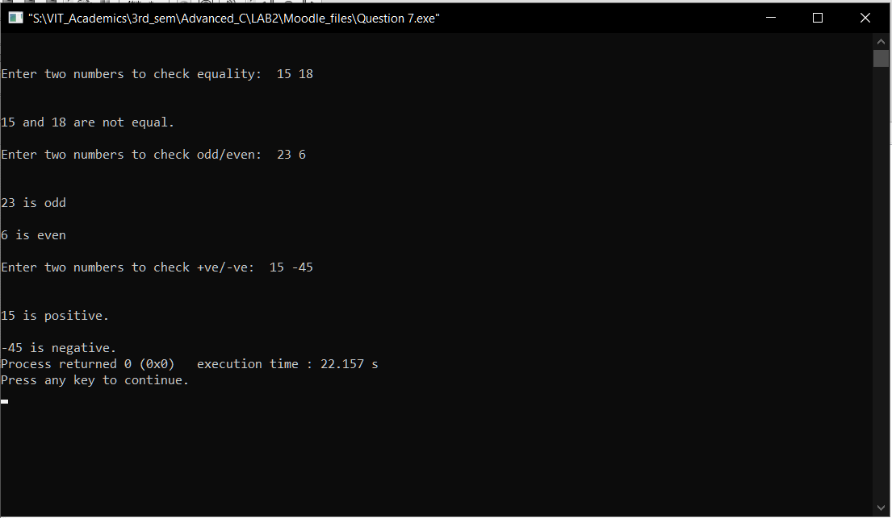

***Test case 2:***

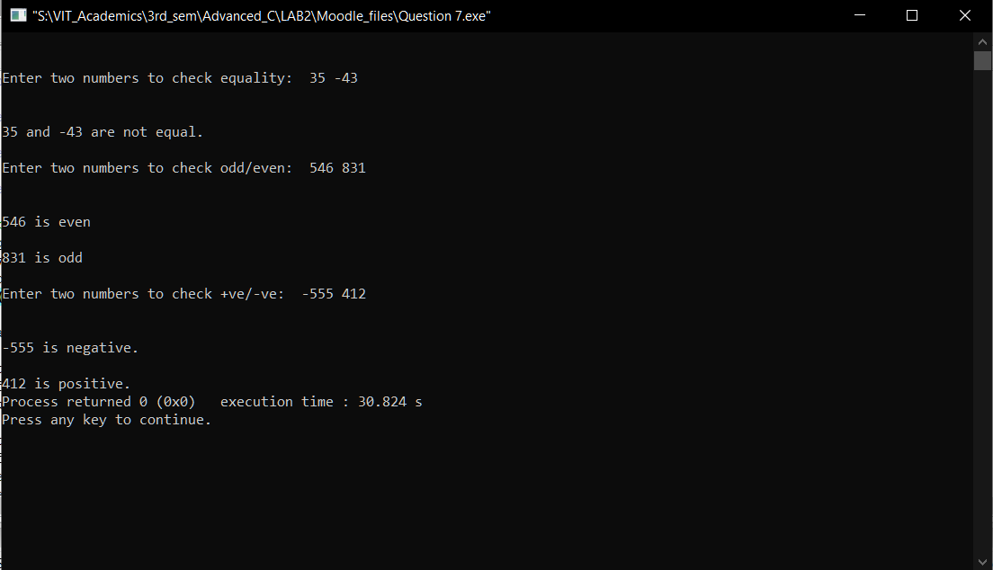

***Question 8:***

*Write a program to convert and display a decimal number in number with base 26, with its digit being represented as alphabets from a – z (0-25). Maximum size of input is 26*26 - 1.*

*Eg.*

*Inp = 25, out= az;*

*inp = 26, out = ba;*

*inp=52, out=ca.*

***Codes:***

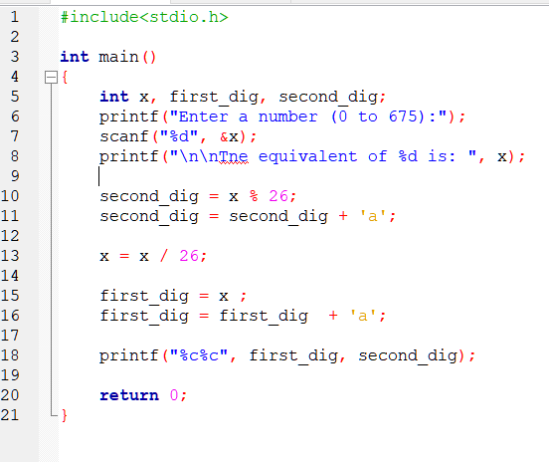

***Test cases:***

